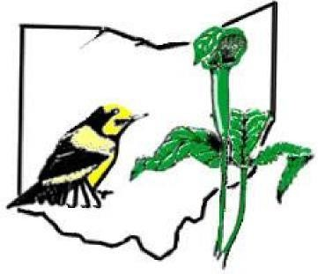
North Coast Open Registration Form
(Must be submitted the Wednesday prior to the scheduled event which is usually the 3rd Friday/Saturday in May)

Team Name:

Team Captain:

Address:

Phone number:

E-mail address:

Team Member 2:
Team Member 3:
Team Member 4:
Team Member 5:
This team will be competing in the following division; check one (see Rules on TNA website):
___ Junior ___ Senior ___Open ___ Freestyle ____Human Powered
Send to NCO, c/o Matt Kemp, 2452 Orchard Rd., Ottawa Hills, Ohio 43406; or email to mattkemp04@gmail.com
We agree to abide by the official rules of the North Coast Open and the decisions of the Event Coordinator; to be courteous to our competitors and all other users of the parks, preserves and roadways during the competition; and to conduct ourselves at all times in such a manner as to enhance the reputation of the North Coast Open, the Toledo Naturalists' Association, and birding in general. We assume the risk of any activities associated with this competition and agree to release and hold harmless the Toledo Naturalists’ Association from any claims relating to such activities.

______________________ __________________________________
Team Captain Signature

______________________
Date

